**Table of Contents**

**Chapter Particulars Page No.**

1. Introduction…………………………………………………………….3
2. Technology used……………………………………………………….3
3. Modules………………………………………………………...............4
4. Screen Shots [Including figure numbers]………………………………5
5. GitHub link and video presentation link……………………….............6



**Project Report**

**On**

**YOU-demy**

Submitted to

**LOVELY PROFESSIONAL UNIVERSITY**

in partial fulfillment of the requirements for the award of degree of

**Bachelor of Computer Science and Engineering**

**Submitted By Submitted to**

**Yash Kaudinya Ms. Navneet kaur**

**11718107**

**LOVELY FACULTY OF TECHNOLOGY & SCIENCES**

**LOVELY PROFESSIONAL UNIVERSITY**

**PUNJAB**

**November 2020**

**CHAPTER 1**

**INTRODUCTION**

* 1. **What is YOU-demy?**

YOU-demy is a web application for learning inspired by Udemy. YOU-demy is intended to be a source of education where the instructors are self-motivated and passionate for the courses they create. Courses are created by those knowledgeable in a subject, and others enroll in the class if they are interested in the subject. This project was built in ~60 hours, but more features will be added as time allows.

* + 1. **YOU_demy Features**

Courses

* Each course can be individually viewed to see additional data and course information.
* After selecting a course to view, a list of suggested similar courses is populated.

Searching/ Browsing

* Users have access to a search feature that allows quick navigation of matching courses.
* Courses can additionally be browsed by clicking on arrow buttons in a row of similar courses.
* Results of searches can be sorted by multiple factors.

**CHAPTER 2**

**TECHNOLOGIES USED**

* Nodejs
* MongoDb
* Ruby
* CSS3
* React

**CHAPTER 3**

**MODULES**

* App
* Bin
* Config
* Db
* Frontend
* Greeting
* Home
* Public
* Reducers
* Search
* Session_form
* Store
* Test
* Util

**CHAPTER 4**

**SCREENSHOTS**



**Fig1. Home Page**

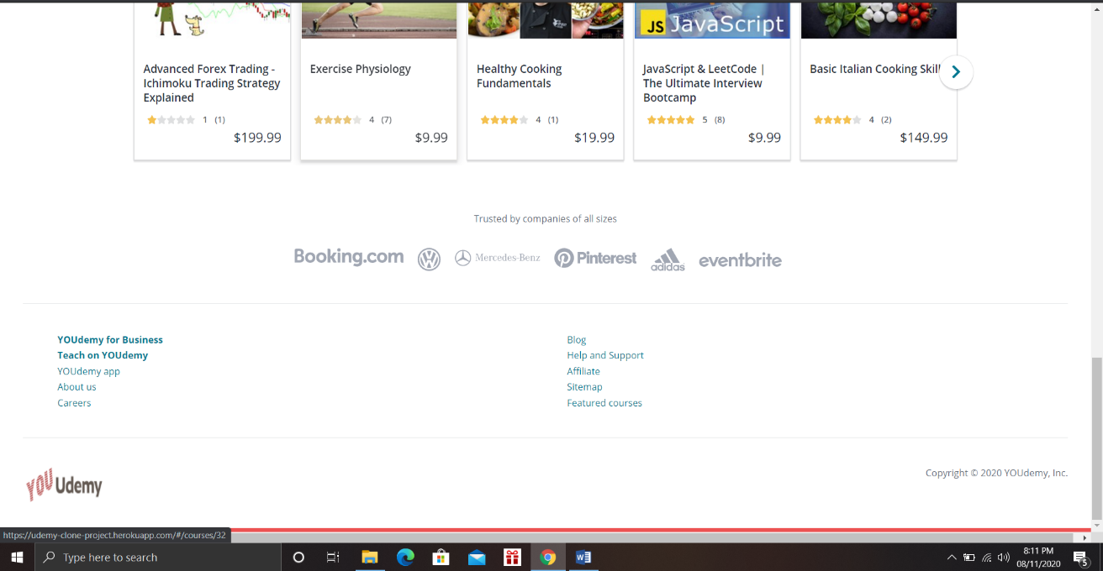

**Fig2. Bottom of Home Page**

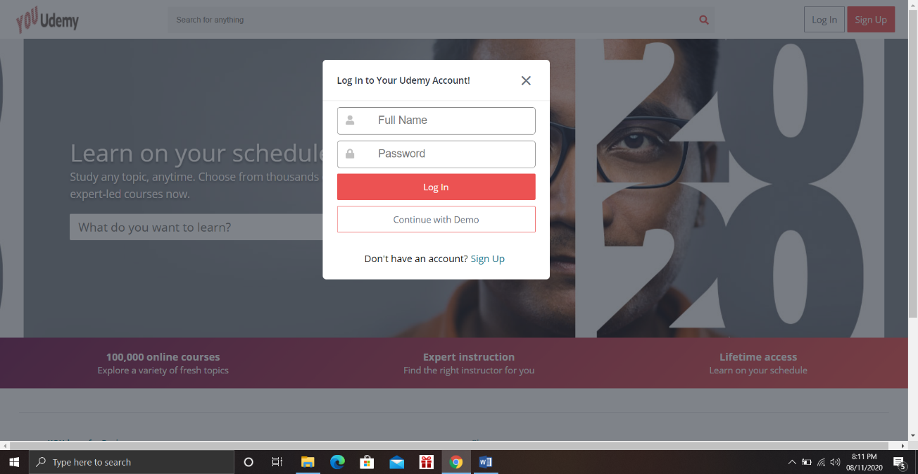

**Fig3. Log In**

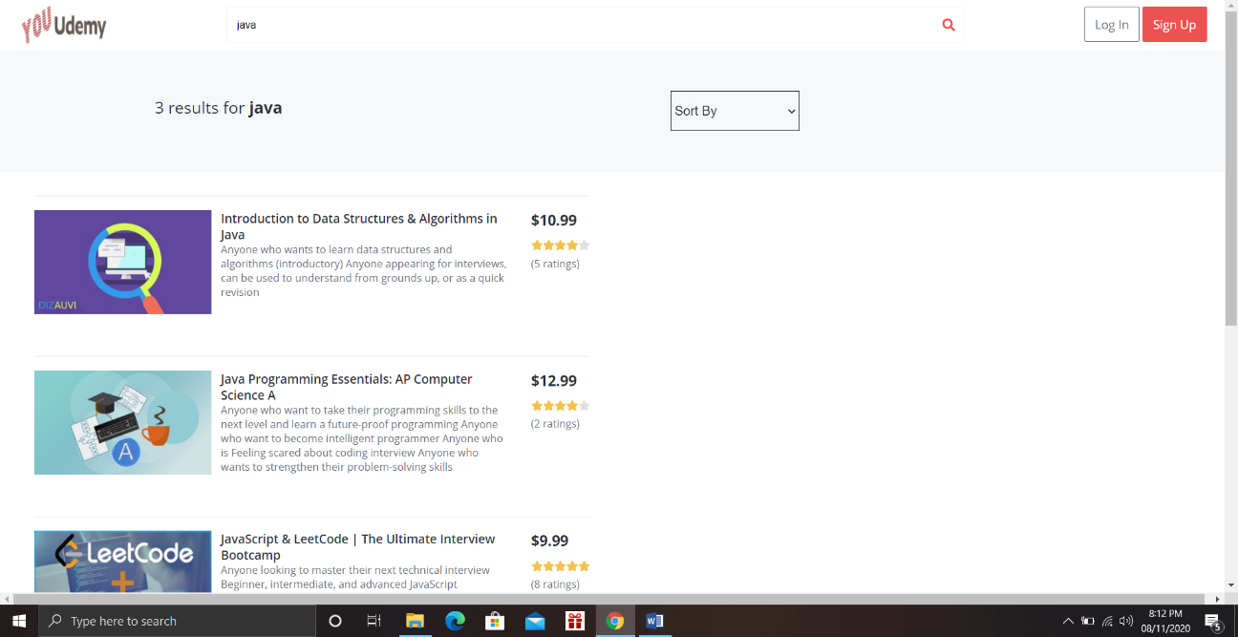

**Fig4. Search**

**CHAPTER 5**

**GITHUB LINK**

https://github.com/DEADSHOT-star/YOU-demy